## Question 1

(a) Draw a diagram to illustrate the 3 types of human memory*.* Explain your answer.

SM

STM/

WM

LTM

Information

attention

rehearsal

recall

SM = sensory memory, from human 5 senses

STM/WM = short term memory or working memory

LTM= long term memory

STM= primary storage of the computers – cache, registers, RAM , volatile

LTM = secondary storage of the computers – HDD, non volatile

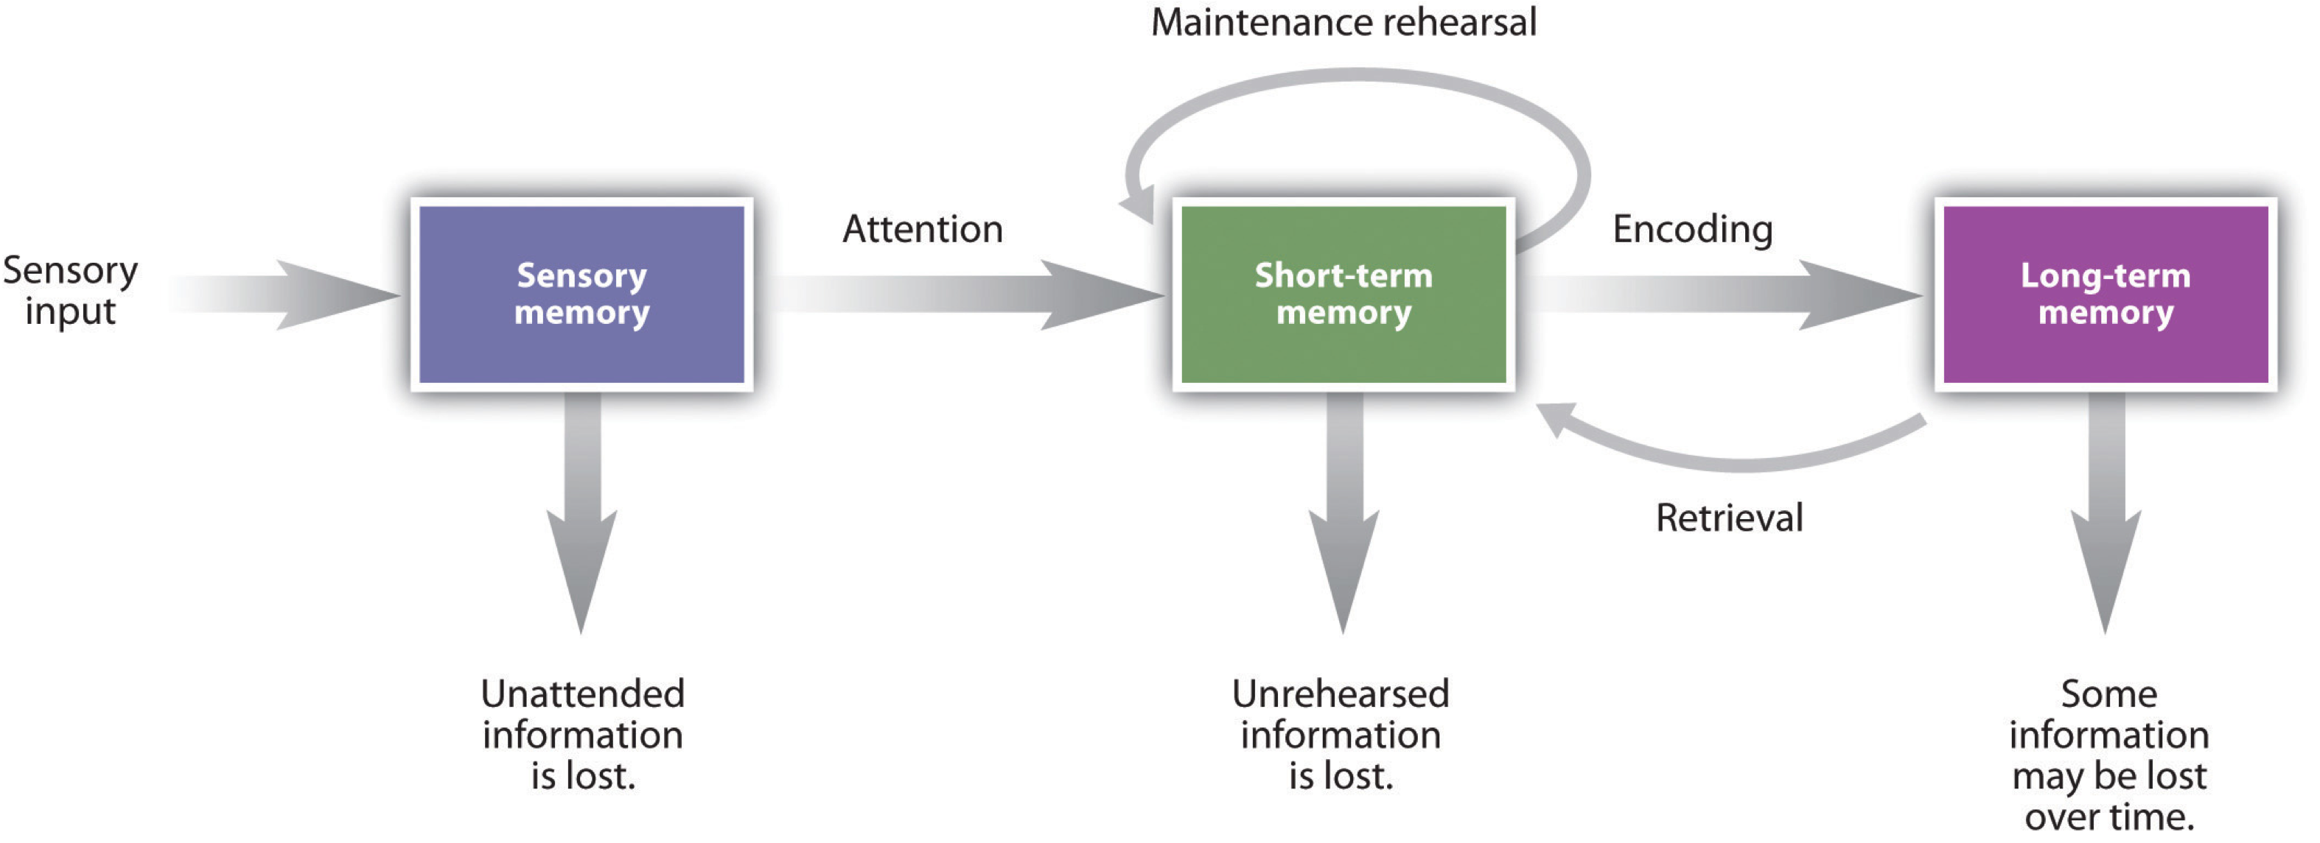

(b) Complete the table below to highlight the differences between STM and LTM.

|  |  |  |
| --- | --- | --- |
|  | STM | LTM |
| CAPACITY | limited  (7±2 …) | unlimited |
| ACCESS | fast | slow |
| DECAY | fast | slow |

(c) According to Miller (1956), STM can hold between 5 to 9 chunks or pieces of information for a very short period of time. Based on Miller’s studies on the capacity of STM, comment whether it is necessary for a designer to limit the number of items displayed in a **menu** to a maximum of 9? Give reasons for your answer.

Not necessary as the user merely has to search through the menu to locate his action. Hence no memory recall is required. However, if the designer intends or wants the user to remember the menu list then then menu has to be limited to that size. Actually depends on the software he want to design desktop applications or mobile applications, mobile applications with the limited screen size, should have a limited menu items.

Besides fitts law and red route principles which stated that we should limit the menu items choices to improved the usability, yes the user may not need to remembers all the menu items, but they need to move their cursor longer and think longer which menu item to choose here.

## Question 2 *(Present your answers using PowerPoint slides)*

(a) Give 2 examples (***own examples***) of interfaces/displays where you are expected to remember more than what is reasonable. Explain your answer.

* A web page with list of documents archives links. Users have to remember which documents they have read or have not.
* A product review website where specifications of products are individually displayed. When user wants to compare the products they have to go back-and-forth between them.
* A coupon code e-mailed to user. The user has to remember the coupon code and type it in the web site.
* An ecommerce website that want the user to memorised the product description, when they placed an orders , in the shopping cart.
* All these examples of UI add mental load or memory load to the user,

(b) Give 2 recommendations on how interfaces/displays should be designed to avoid forcing the user to remember more than what is reasonable. Discuss whether these recommendations must be followed all the time.

* Hyperlink highlights – to help the user remembering and identify which web page they have visited, visited hyperlink different color purple color.
* Product page comparison side-by-side – So user does not need to go back-and-forth to remember the products specifications, provide an option for the user to compare the product they choose.
* Coupon code link – Ensure users don’t have to remember coupon number, copy and paste function can be used or automatically filled in for the users.
* For the ecommerce website when the user add the product to shopping cart, the product description information is automatically filled in the order forms.
* Yes, must be followed to ensure the usability of the systems are achieved, effectiveness, efficiency and satisfactions.

## Question 3

*“In HCI, mental model refers to the user’s current understanding of how “something” works (e.g how a system works). Very often the user’s mental model does not match with what the system actually does”.*

Explain the above statement by using a suitable example*(the example provided must be based on your own experience).*

* A feeling of RELIEF when a task has been accomplished and you know that you are free to move on to the next task and FORGET about the task you have just done. So user gets to know a task is completed and can free up his/her memory for the next task.

For example, during game play, certain scene uses different command keys. To deals with it, these sections of scenes are separated as “levels”. Users are initially reminded of the command keys at that level. Once finished, the user is notified of the level is completed. He/she can feel relieved, forget the command keys and moves on to the next level.

However, if such scenes are not separated into levels, the user has to focus on remembering the keys and that might distract him performing other tasks in the game.

Water faucet – Most people relates opening or closing the tap with rotating the handle. However, in some hot & cold water faucet, rotating the handle adjusts the hot/cold water while opening the tap requires the handle to be lifted up instead. In this case, the design of this hot & cold faucet does not match the user’s mental model. This causes a user to be confused and failed to operate the faucet properly.

<https://uxdesign.cc/the-floppy-disk-save-icon-visual-language-of-an-era-long-gone-93f74efc9f9>

